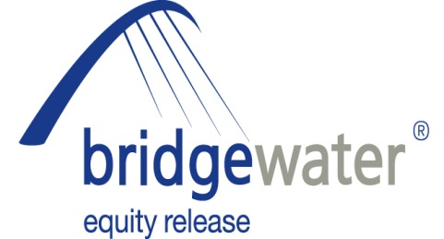

14 May 2013

BRIDGEWATER ANNOUNCE ROUNDTABLE
ADVISER WORKSHOP

Bridgewater Equity Release, the home reversion specialist, has today (14th May 2013) announced a roundtable workshop event designed to support specialist equity release advisers.

The workshop will allow advisers to ask questions of three equity release experts: Chris Prior of Bridgewater, Peter Barton of Ashfords Solicitors – who will cover the legal implications of equity release - and Gareth Morgan of Ferret Systems who will cover State benefits.

The roundtable event will take place at Ashfords’ offices on the 13th June at Accurist House, 44 Baker Street, London W1U 7AJ. The event opens at 10am for coffee, the roundtable will begin at 10.30am and finish at 12.30 followed by lunch and the opportunity for further networking.

There is limited availability for places so interested advisers should contact Richard Hadley immediately on rhadley@bridgewaterequityrelease.co.uk

Chris Prior, Manager, Sales and Distribution at Bridgewater Equity Release, commented:

“Equity release advisers are at the heart of our business and our aim is always to offer a range of support and information to help them in their business activities. This workshop has been put together to offer advisers a chance to quiz three experts on any equity release-related topic they might have. There will be no presentations, instead we are opening the floor to our attendees and they can come with their own agenda about the topics we cover.

“In both Peter and Gareth we have two leaders in their field with regards to both the legal and State benefit implications of equity release. I will be there to offer advice on areas such as marketing, lead generation, product choice and solutions, and any other subjects that come up. We hope that advisers who attend will also feel able to share their own experiences and expertise as we firmly believe that the sector will grow in both size and respect if we are able to work together. The Bridgewater team look forward to welcoming all attendees to next month’s workshop.”

For further information on Bridgewater Equity Release, please visit: www.bridgewaterequityrelease.co.uk

ENDS

For further information please contact:
Chris Prior, Manager Sales and Distribution, Bridgewater Equity Release, Mobile: 07917 463990
Kurt Mueller, Director of Corporate Affairs, Grainger plc (parent company of Bridgewater Equity Release), Mobile: 07584 235088; kmueller@graingerplc.co.uk
Rob Griffiths, White Dragon Communications Ltd, Mobile: 07983 641566; rob@whitedragoncomms.co.uk
Barney McCarthy, White Dragon Communications, Mobile: 07872 956711; barney@whitedragoncomms.co.uk

Notes to editors

- Bridgewater Equity Release Limited was founded in 1998 and is the UK’s leading provider of home reversion plans with over 4,000 home reversion customers.
- Bridgewater Equity Release Limited is an award-winning provider and a member of the Equity Release Council, the trade association dedicated to the protection of plan holders and the promotion of safe home income and equity release plans. Bridgewater offers a range of plans which abide by the Council’s Code of Practice.
- It is committed to ensuring that all its customers are fully aware of the scheme they are entering into and have considered all alternatives.
- Bridgewater Equity Release is a subsidiary of Grainger plc, which was established in 1912.
- Bridgewater Equity Release is a registered trade mark of Grainger plc. All rights reserved.
- Grainger plc is the UK’s largest specialist residential property owner and manager traded on the London Stock Exchange. Grainger’s business activities in the UK and Germany cover ownership, trading, fund management, property management and development of residential property. Grainger is the leading provider of home reversions, an equity release product, through Bridgewater Equity Release. Grainger has approximately £2.1 billion of wholly-owned property assets, £2.8 billion of assets under management and manages approximately 26,400 properties in the UK and Germany.

Bridgewater Equity Release Ltd
Citygate, St James’ Boulevard
Newcastle upon Tyne
Tyne and Wear
NE1 4JE
Tel: 0191-242 4820
Fax: 0191-269 5974
E-mail: enquiries@bridgewaterequityrelease.co.uk

