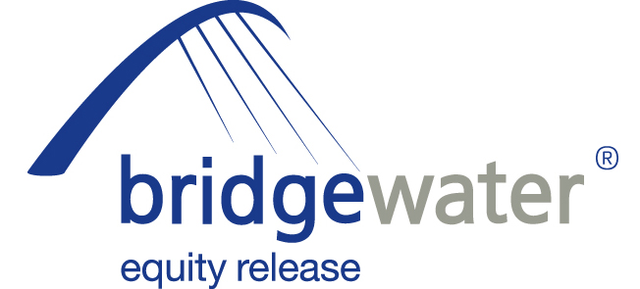

23 October 2012

BRIDGEWATER UNVEILS ENHANCED
QUOTE CALCULATOR

Bridgewater Equity Release, the home reversion specialist, has today (23rd October 2012) launched a new quick quote calculator to help make life easier for advisers during the sales process.

The tool is more accurate than any other system that has access to Bridgewater’s rates and gives advisers the ability to quote on all its products, including the Secured Escalating Release Plan.

Advisers are not required to log-in to take advantage of the calculator, meaning they can easily access it during discussions with clients and conveniently use it for reference and comparative purposes.

It also helps navigate users through the suitability process as advisers not sure of what product would be most appropriate for their client are able to adjust product and requirement information without having to re-input basic client details.

The calculator has also been pre-programmed with all of Bridgewater’s criteria, so it will automatically let advisers know if their client’s needs are within its parameters in terms of age and release limits. There is also functionality for advisers to obtain quotes for further releases for existing customers, which was not previously available.

Chris Prior, Manager Sales and Distribution at Bridgewater Equity Release, commented:

“The thought process behind the creation of our new quick quote calculator was to give advisers greater flexibility in what they can do across our entire product range. With our original tool advisers could simply find out the maximum release or the percentage of property needed for a partial release; the enhanced functionality of the new calculator means they are now able to establish what products are likely to be suitable and whether their clients’ needs fit within our parameters.

“It is important that we continue to do everything we can to make the equity release adviser’s job as easy as possible and to help them understand and explain our products to their clients. Although there are a number of different factors to consider when advising on equity release, and whether individual clients are suitable or not, a lot of the time people want to know exactly how much equity they can release and our enhanced calculator lets advisers access this information at the click of a button. As a forward-thinking provider, it is vital that we harness technology to our benefit to ensure the advice process is as transparent, convenient and efficient as possible.”

Advisers wishing to start taking advantage of the new quick quote calculator can do so at: www.bridgewaterquickquotecalculator.co.uk

ENDS

For further information please contact:
Chris Prior, Manager Sales and Distribution, Bridgewater Equity Release, Mobile: 07917 463990
Kurt Mueller, Director of Corporate Affairs, Grainger plc (parent company of Bridgewater Equity Release), Mobile: 07584 235088; kmueller@graingerplc.co.uk
Rob Griffiths, White Dragon Communications Ltd, Mobile: 07983 641566; rob@whitedragoncomms.co.uk
Barney McCarthy, White Dragon Communications, Mobile: 07872 956711; barney@whitedragoncomms.co.uk

Notes to editors

- Bridgewater Equity Release Limited was founded in 1998 and is the UK’s leading provider of home reversion plans with over 4,000 home reversion customers.
- Bridgewater Equity Release Limited is an award-winning provider and a member of the Equity Release Council, the trade association dedicated to the protection of plan holders and the promotion of safe home income and equity release plans. Bridgewater offers a range of plans which abide by the Council’s Code of Practice.
- It is committed to ensuring that all its customers are fully aware of the scheme they are entering into and have considered all alternatives.
- Bridgewater Equity Release is a subsidiary of Grainger plc, which was established in 1912.
- Bridgewater Equity Release is a registered trade mark of Grainger plc. All rights reserved.
- Grainger plc is the UK’s largest specialist residential property owner and manager traded on the London Stock Exchange. Grainger’s business activities in the UK and Germany cover ownership, trading, fund management, property management and development of residential property. Grainger is the leading provider of home reversions, an equity release product, through Bridgewater Equity Release. Grainger has approximately £2.1 billion of wholly-owned property assets, £2.8 billion of assets under management and manages approximately 26,400 properties in the UK and Germany.

Bridgewater Equity Release Ltd
Citygate, St James’ Boulevard
Newcastle upon Tyne
Tyne and Wear
NE1 4JE
Tel: 0191-242 4820
Fax: 0191-269 5974
E-mail: enquiries@bridgewaterequityrelease.co.uk

