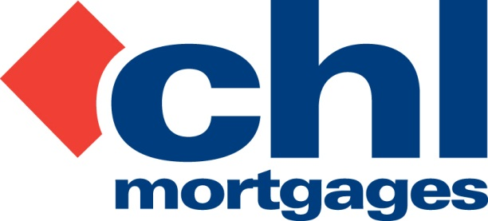

12 November 2012

PRESS RELEASE

CHL ARREAR LEVELS CONTINUE TO FALL

Specialist lender, CHL Mortgages, has today (12th November 2012) revealed a continuing fall in arrear levels for its buy-to-let mortgage book.

As at the end of October 2012, out of 42,000 live mortgage accounts, only 572 (1.36%) were in three-month arrears while those accounts one month in arrears dropped below 900 to 896 (2.13%) for the first time since mid-October 2008. Over the month this meant a decrease of 121 in total accounts in arrears.

CHL’s arrears levels are now at a four and a half year low and are comfortably beating its own 2012 best estimates set at the start of the year.

Also in October CHL’s asset management function saw the highest monthly rent receipt for all those properties now managed by a Receiver of Rent (RoR). The overall position of those properties with an RoR continued to improve – of those properties that can be rented out 95% have tenant occupancy. Rental income percentage levels for those properties now stands at 165%, a significant increase given the vast majority of the loans originated were underwritten at 125%.

Finally, a number of distressed properties which were recently sold at two auctions bettered their reserves by a considerable margin. An auction in the North saw the six properties average 168% of the reserve price, while 12 properties in the South fetched, on average, 128% of the reserve.

Bob Young, Managing Director at CHL Mortgages, commented:

“Even by our own recent standards October has been a particularly positive month for arrears levels on our book with a number of benchmarks beaten. The fact we now have a mortgage book which has reached a four and a half year low in terms of arrears is very pleasing as is the fact we have consistently beaten those best case scenario forecasts we made at the start of the year. On our one-month arrear levels we have broken through the 1,000 and 900 barrier during the year and, looking ahead, we believe we may just reach the low 800s before the end of 2012.

“Other indicators of the quality of the book are also abundant with examples such as our ability to bring in the highest monthly rent receipt ever during October being one of the stand-out highlights. We have also benefited from a continually improved timescale when it comes to the turnaround of maintenance and lettings work, even though we have set those working in these departments particularly stretching targets. These are consistently hit and often beaten, and this is testament to the hard work and dedication that all CHL members of staff active in this area are putting in.

“The challenge now of course is not to rest on our laurels but to continually improve on our figures. We know there is still room for improvement and all members of the CHL management team and those who work across the business are committed to ensuring that our numbers continue to go in the right direction.”

For full information on CHL visit: www.chlmortgages.co.uk

ENDS

For further information please contact:
Bob Young, Managing Director, CHL Mortgages
Tel: 01252 365890
Rob Griffiths, White Dragon Communications Ltd
Mobile: 07983 641566, rob@whitedragoncomms.co.uk
Barney McCarthy, White Dragon Communications Ltd
Mobile: 07872 956711 barney@whitedragoncomms.co.uk

NOTES TO EDITORS

- CHL Mortgages has been offering specialist mortgage solutions since 1992. It is based in Fleet, Hampshire and is part of the Irish Life & Permanent Group.
- CHL Mortgages is a pioneer of both buy-to-let mortgages and self-certification mortgage products for the self-employed. It has now grown to be a leading player in these sectors.
- CHL products are designed to meet the needs of various customers, ensuring CHL Mortgages lends responsibly and treats customers fairly.

CHL Mortgages
Admiral House, Harlington Way, Fleet, Hampshire GU51 4YA
Tel: 01252 812271
Fax: 01252 811826
Website: www.chlmortgages.co.uk

